1. Create project structure like this:

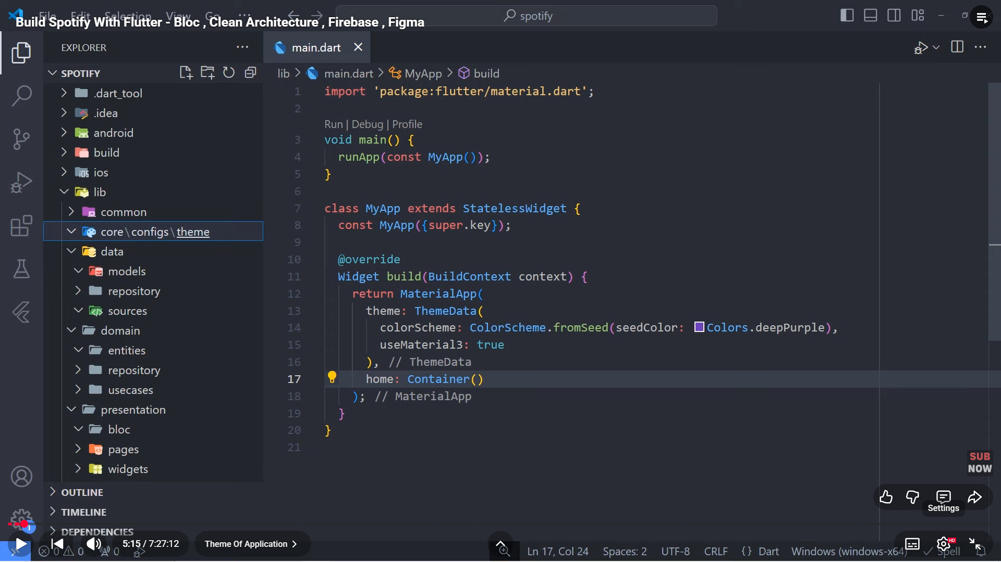

1. App_colors:

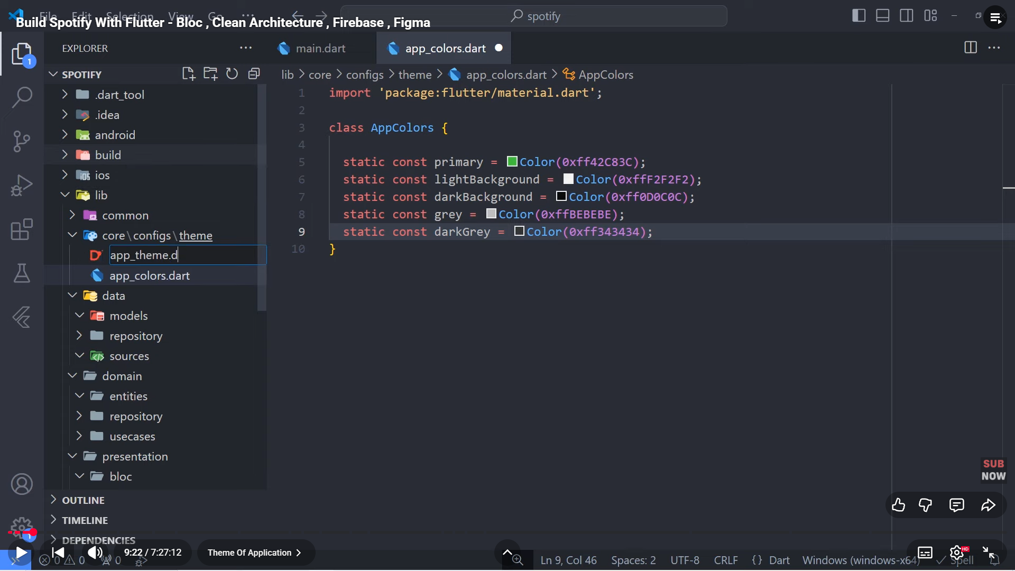

1. App_theme:

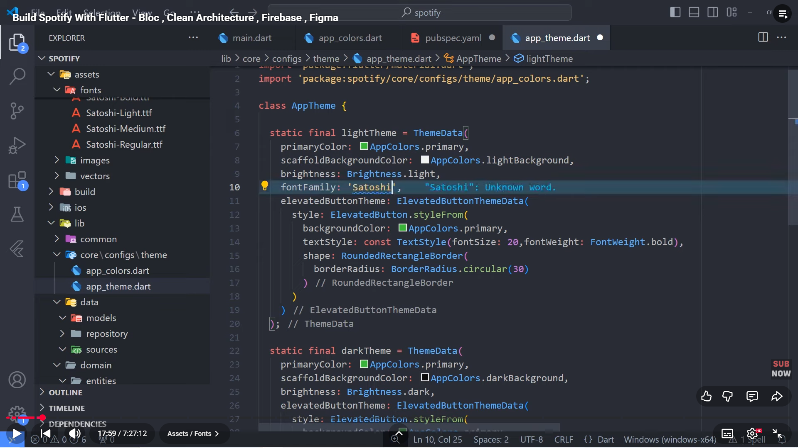

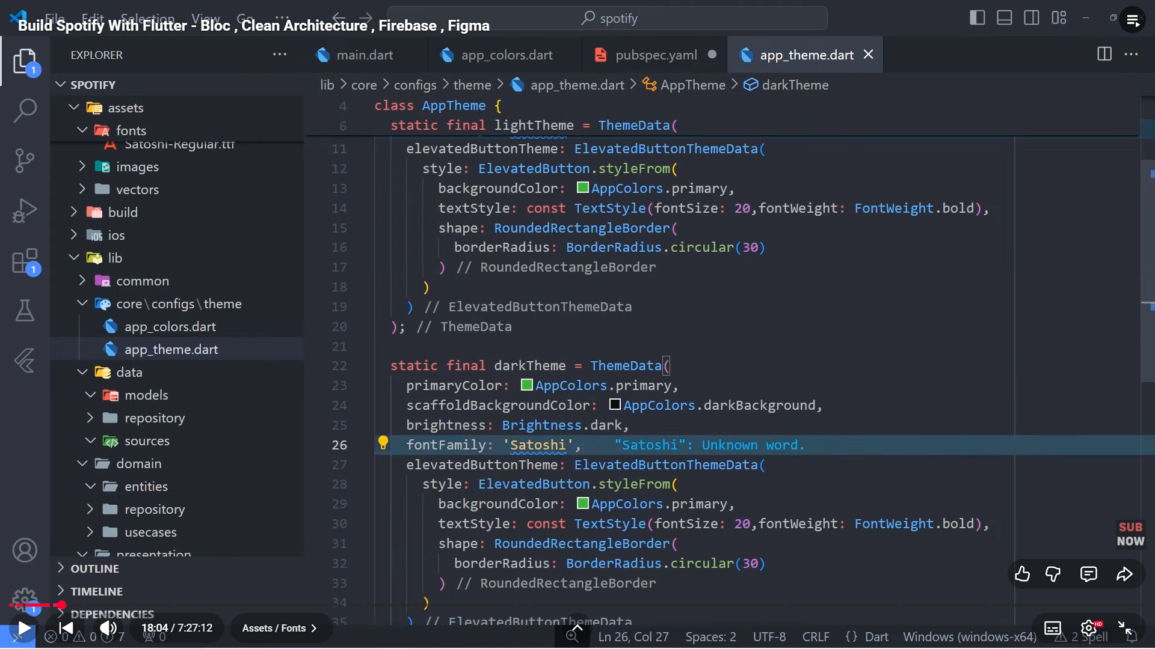

1. Configure:

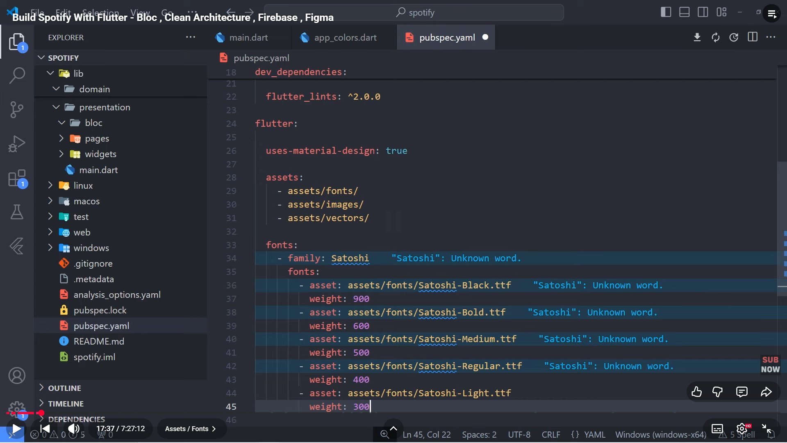

1. Create folder presentation/splash/bloc, pages/splash, widgets and assets inside core/configs

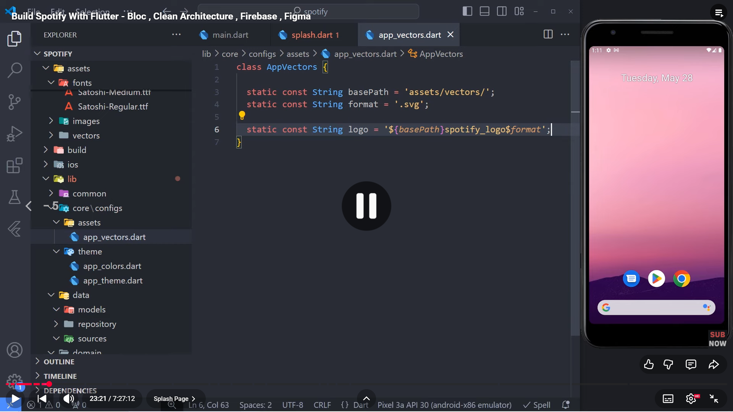

1. Add flutter_svg: in pubspec.yml after cupertino_icons: ^1.0.8
2. Create future function inside splash called redirect to startPage
3. Create file widgets/button/basic_app_button inside common

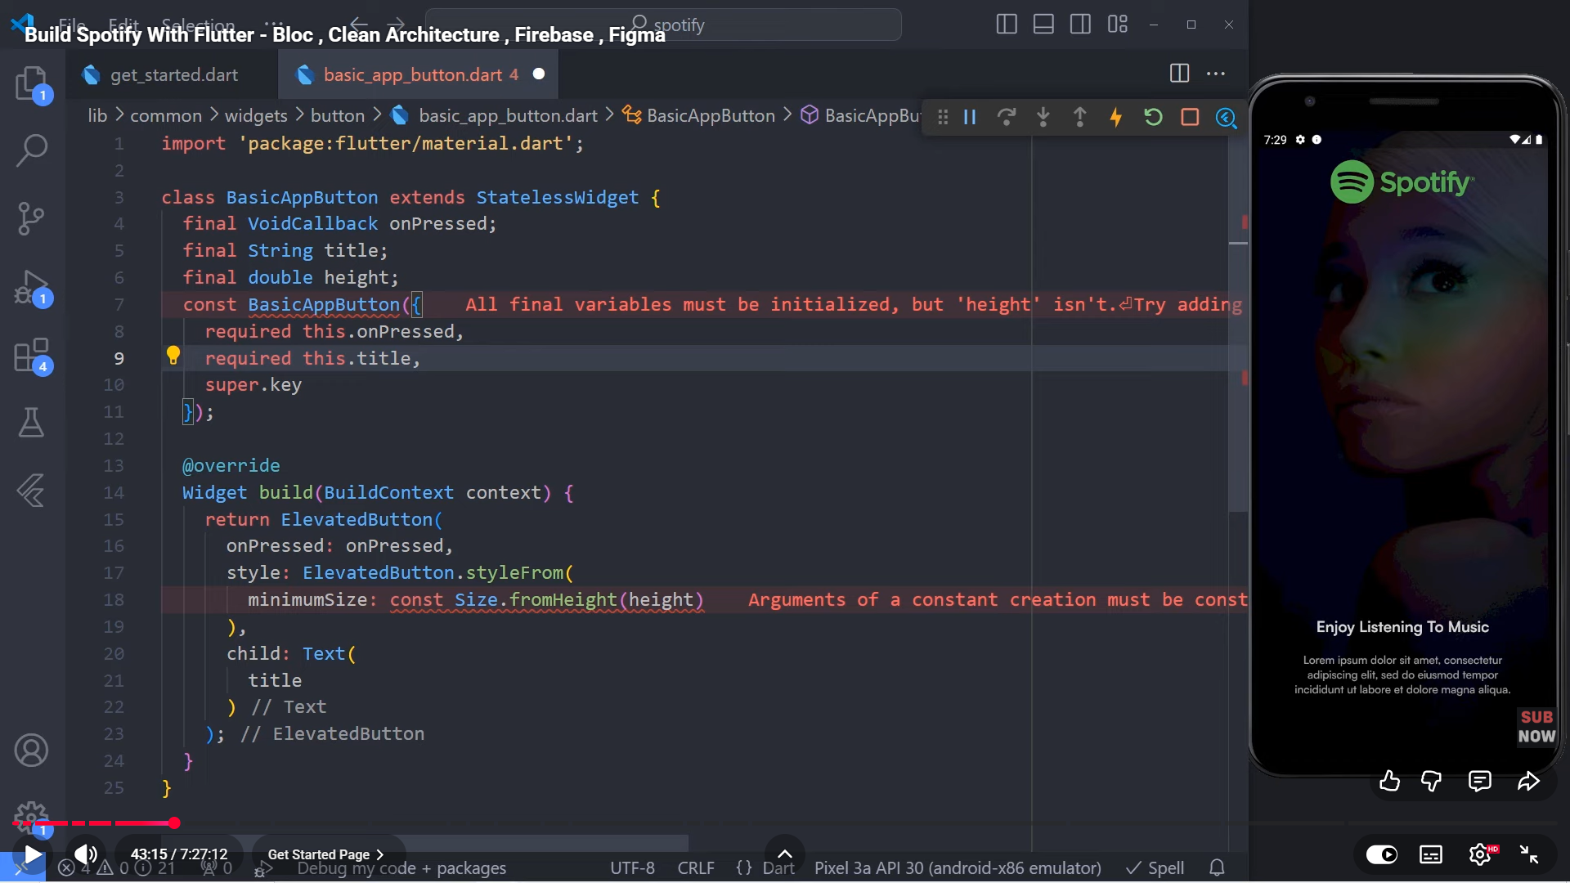

1. Get started will be like this:

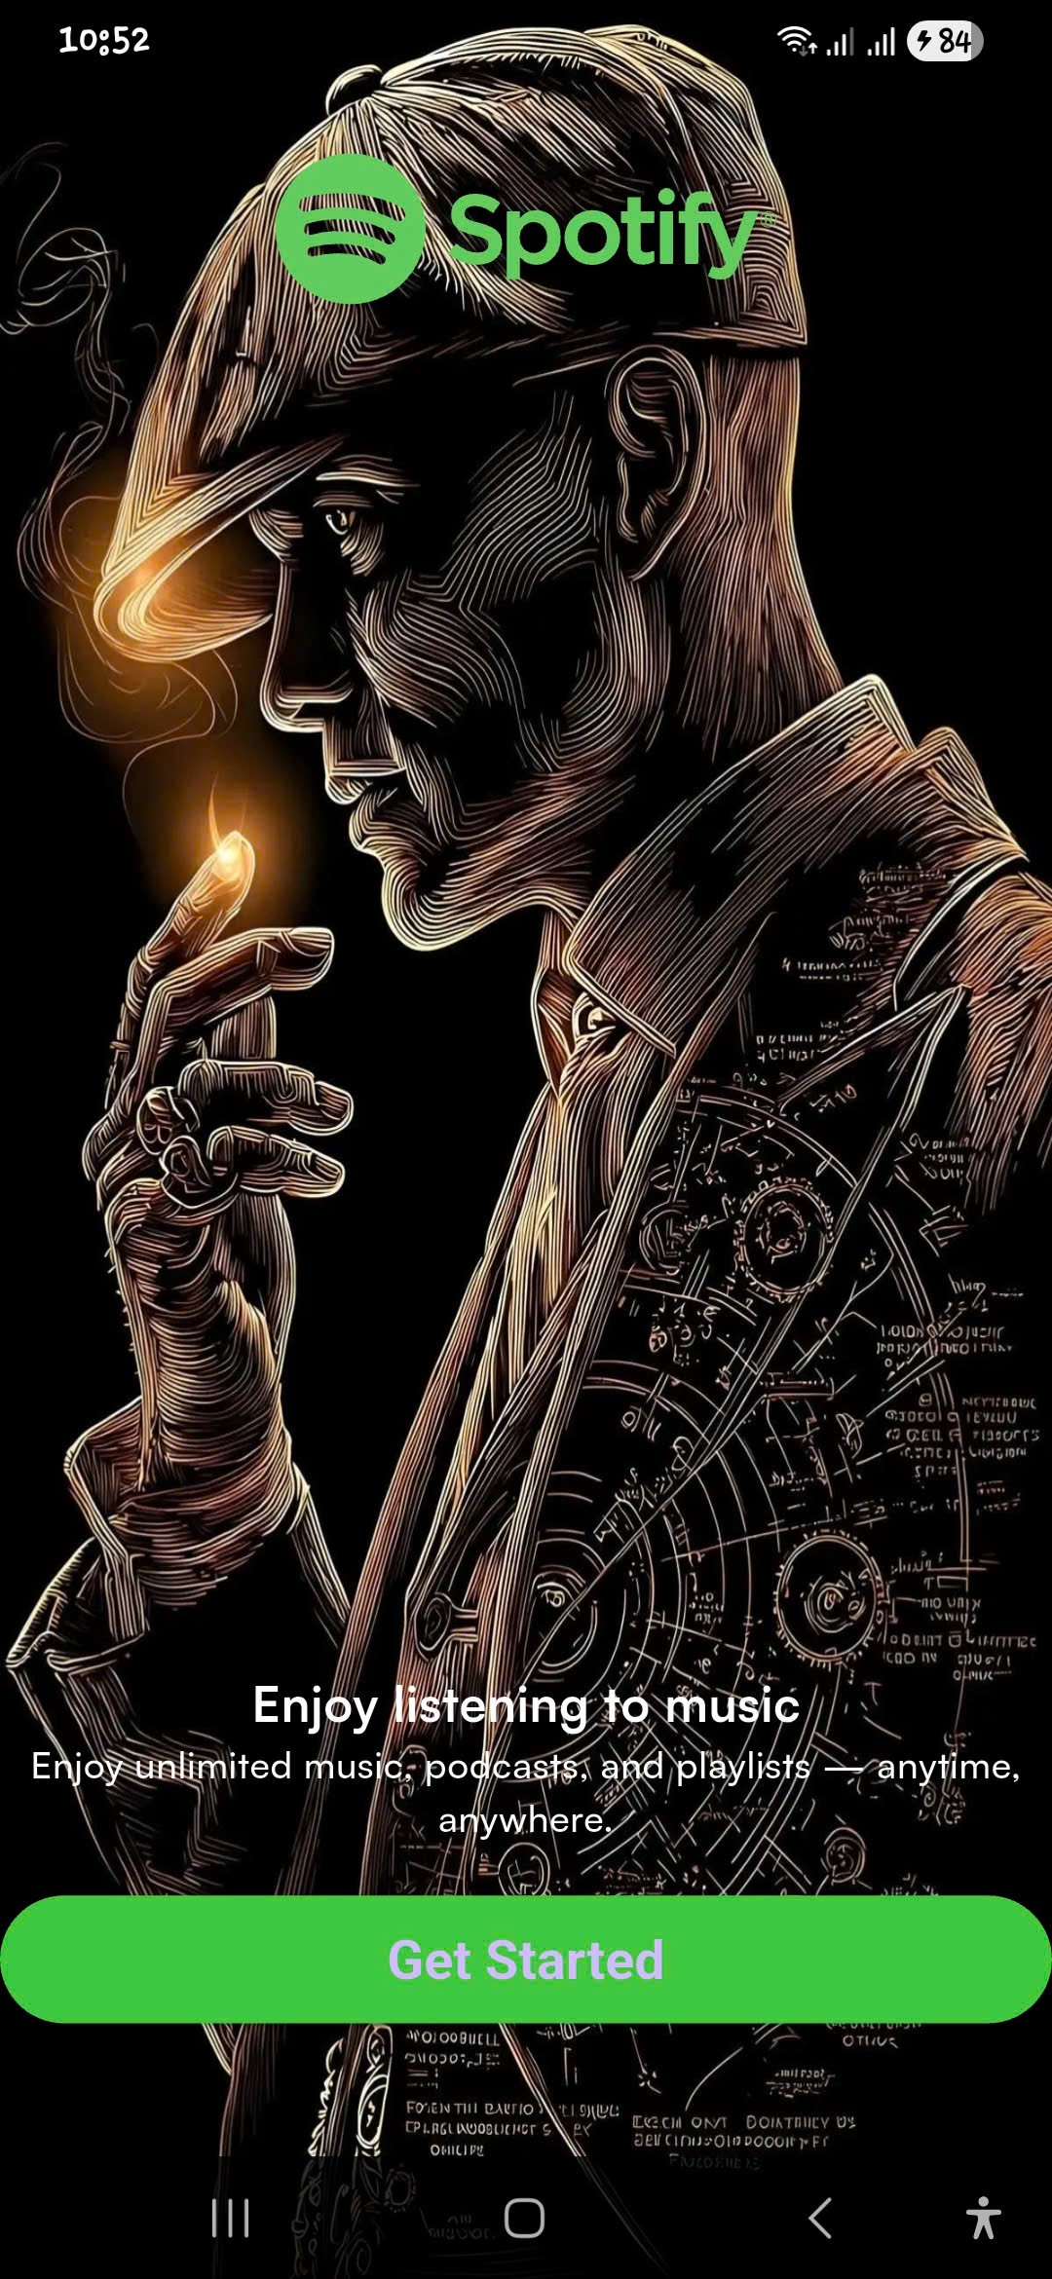

1. Create folder choose_mode in presentation
2. Choose_made will be like this:



1. Use bloc to manage state:

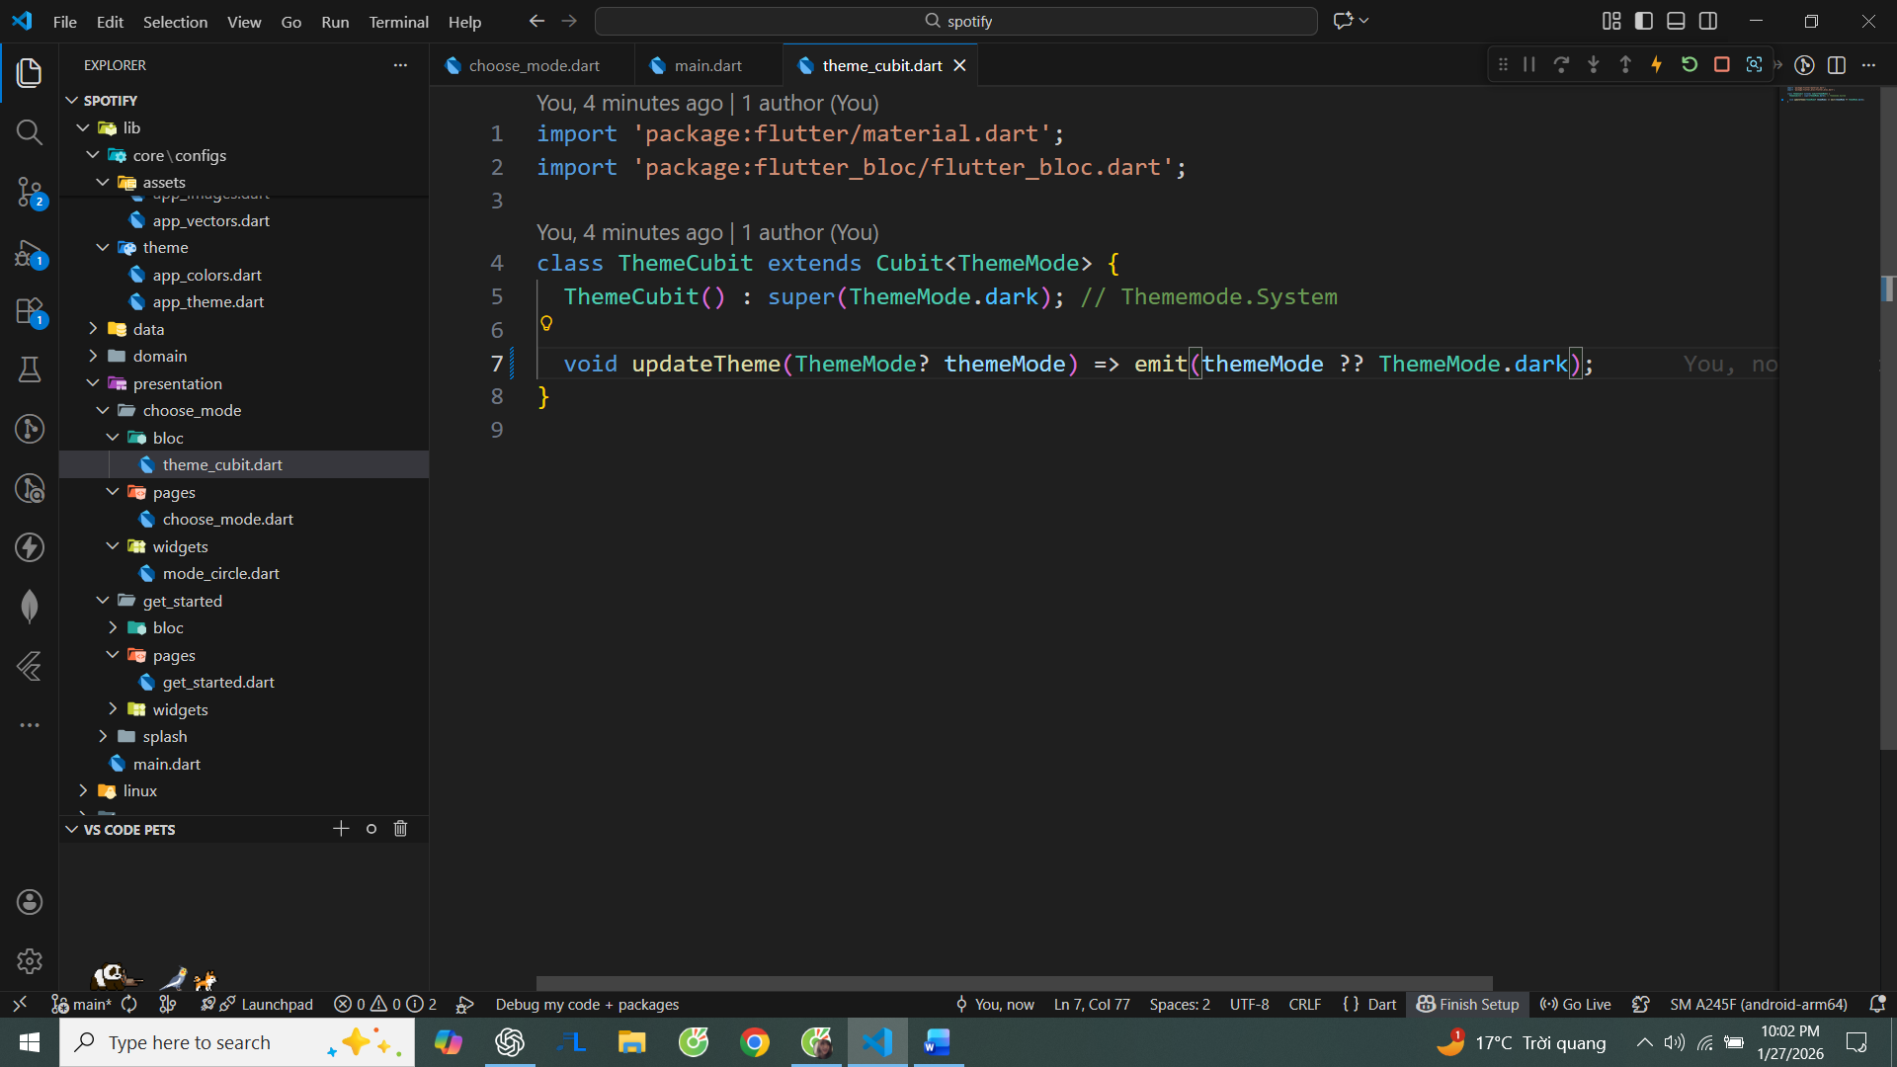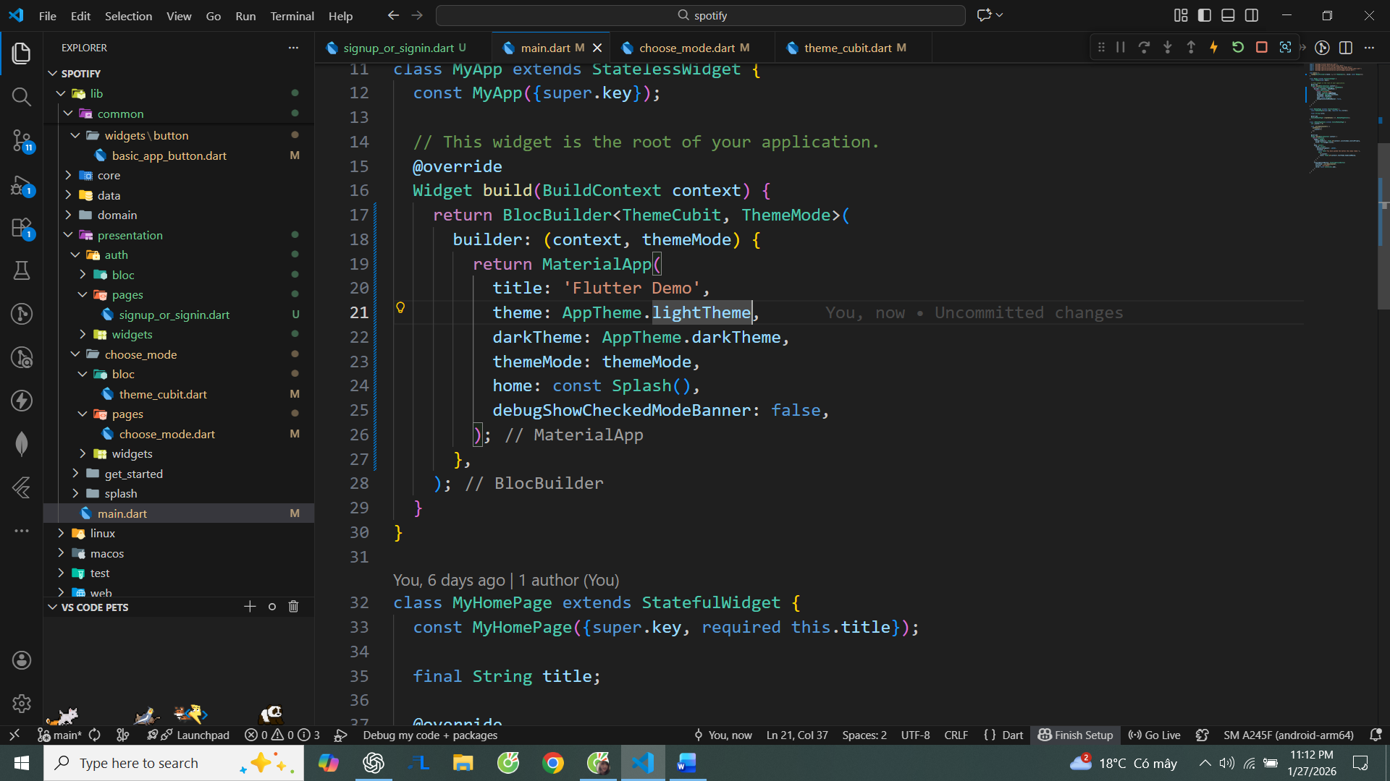

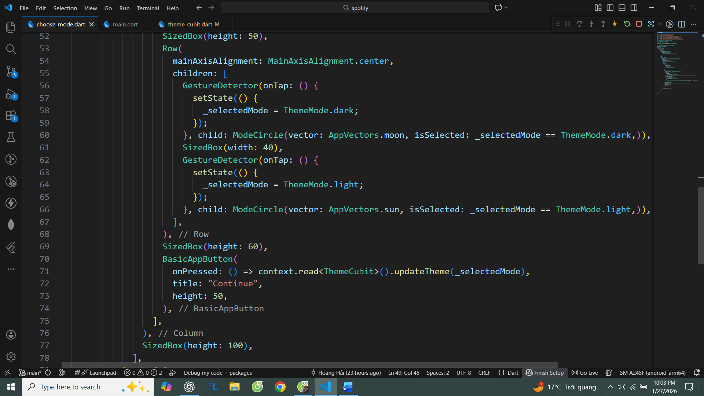

1. ModeCircle:

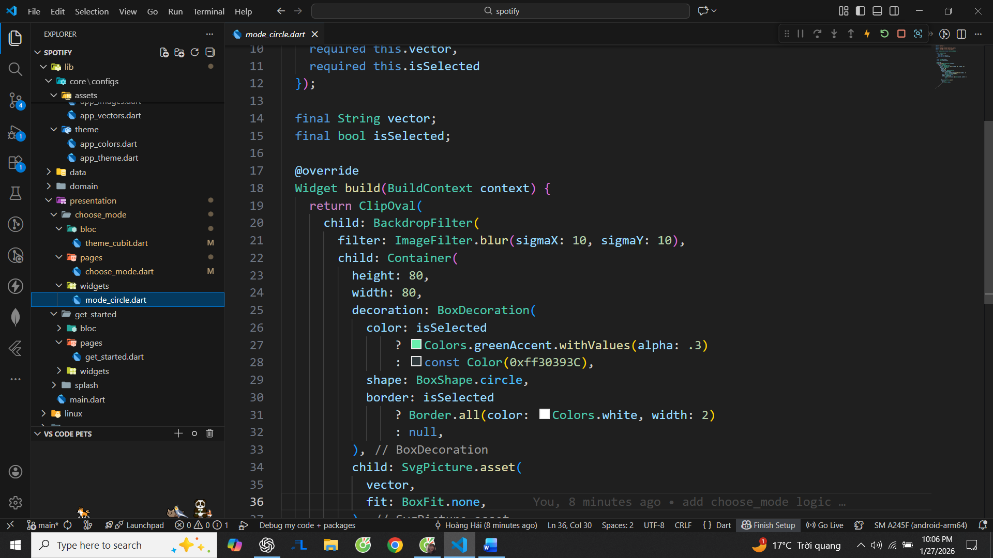

1. Create folder auth in presentation and create signup_or_signin.dart
2. Create folder helpers in common:

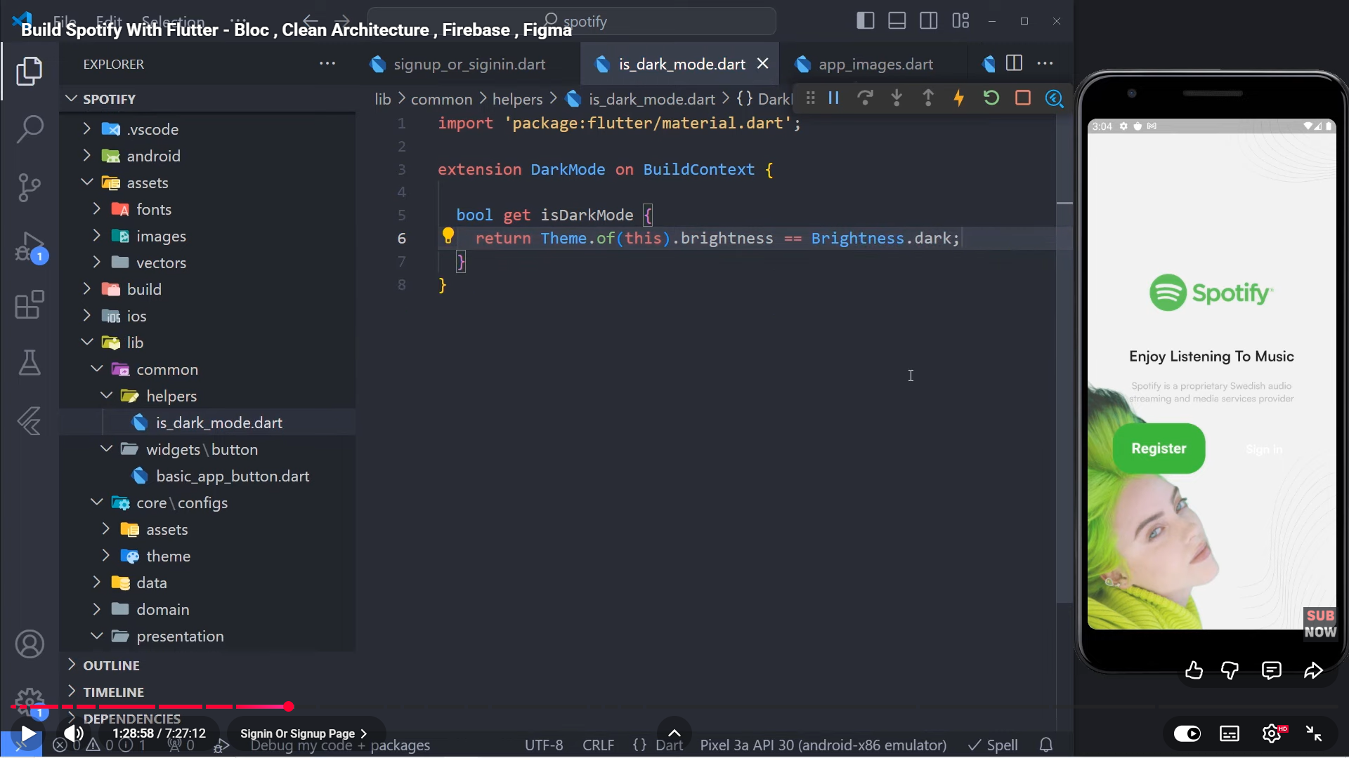

1. Sign up or sign in page will be like this:

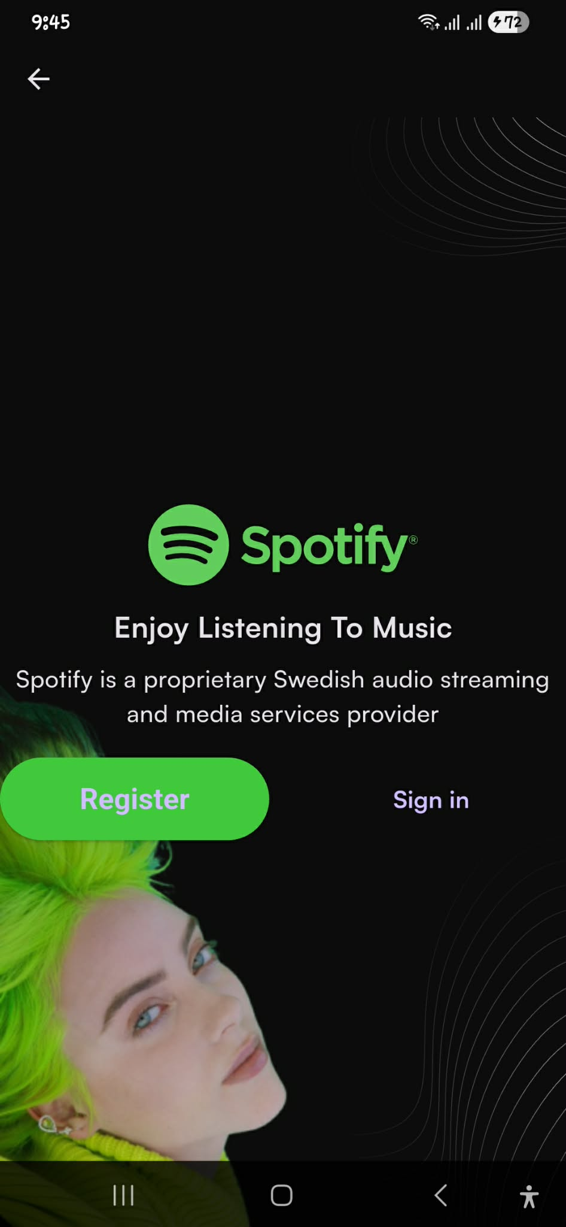

1. Add additional information into app_theme:

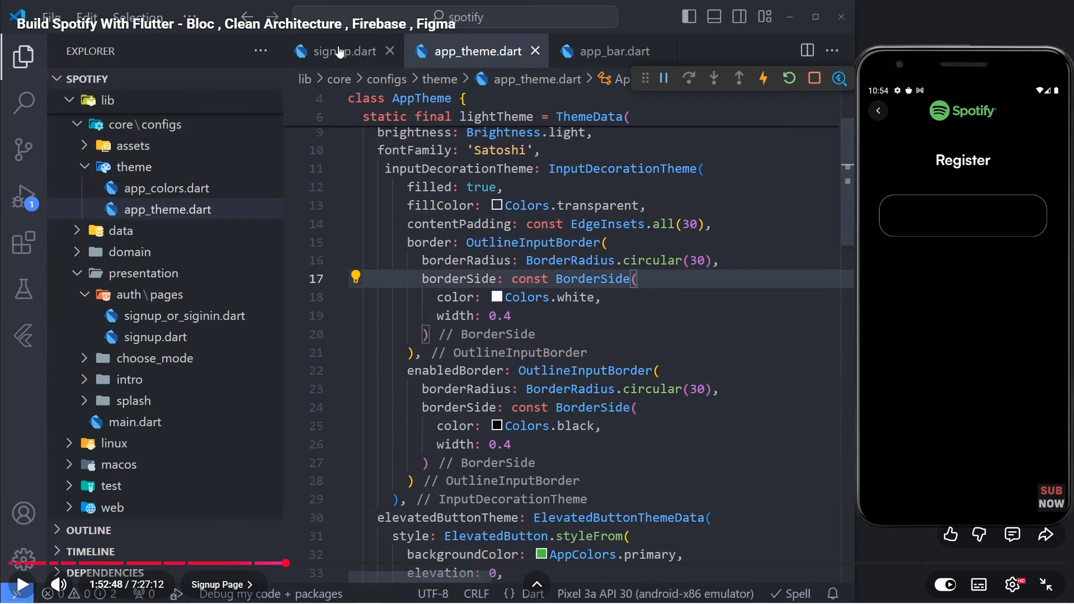

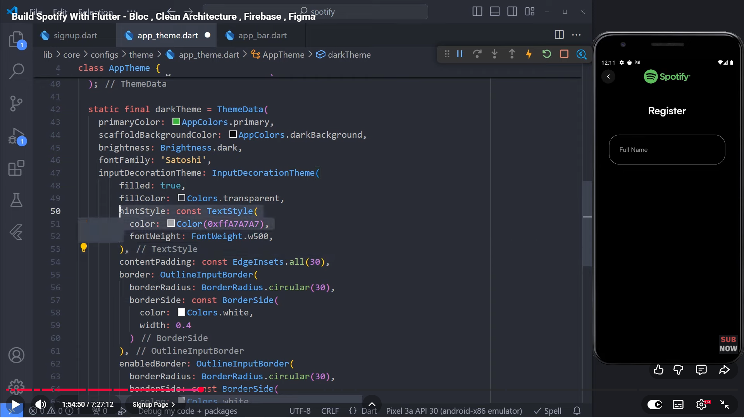

1. Register will be like this:

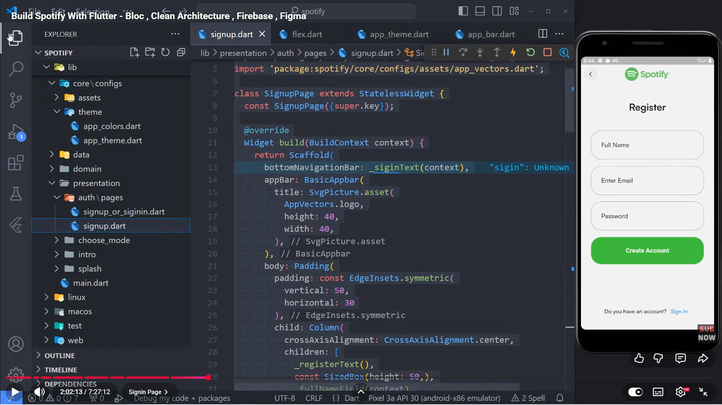

**Note:**  
Make sure your ThemeCubit is defined **once** and imported from the **same file everywhere**.  
Even if two cubits have identical code, Flutter treats them as different types if they come from different paths, which will cause ProviderNotFoundException.

**Note:** Always import ThemeCubit from a single source. Different import paths = different cubit types.

1. Configure firebase in the project
2. Create folder auth in domain/entities and create file user.dart

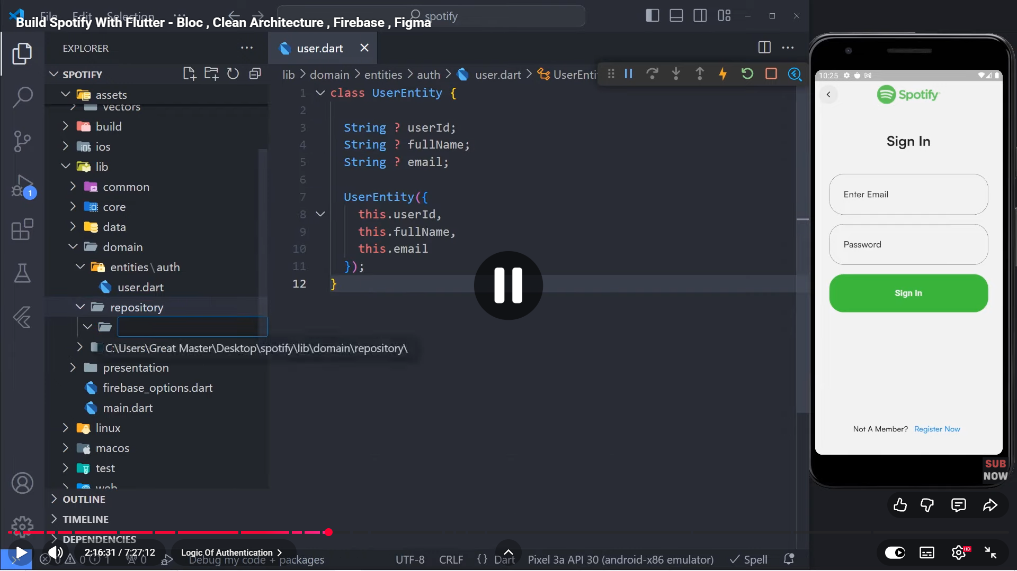

1. Create folder auth in domain/repository and create file auth.dart

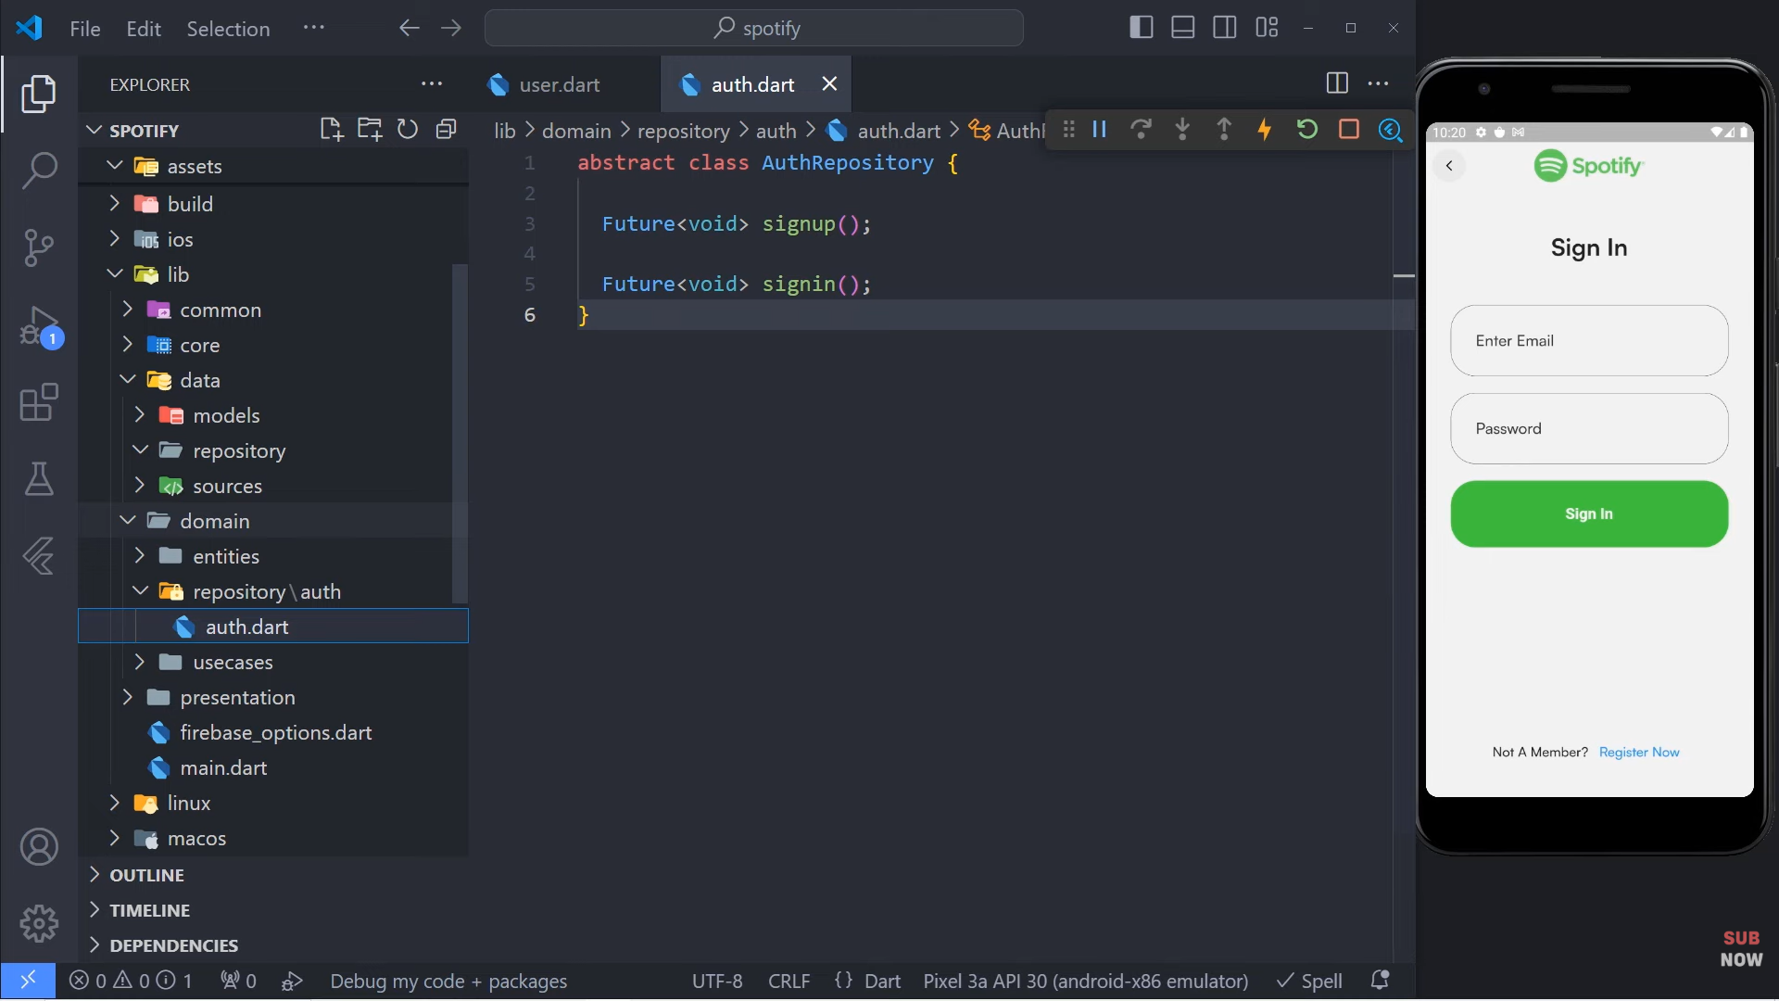

1. Create folder auth in data/sources and create file auth_firebase_service.dart
2. Add firebase_auth in pubspec.yaml
3. Create file create_user_req.dart in the models/auth

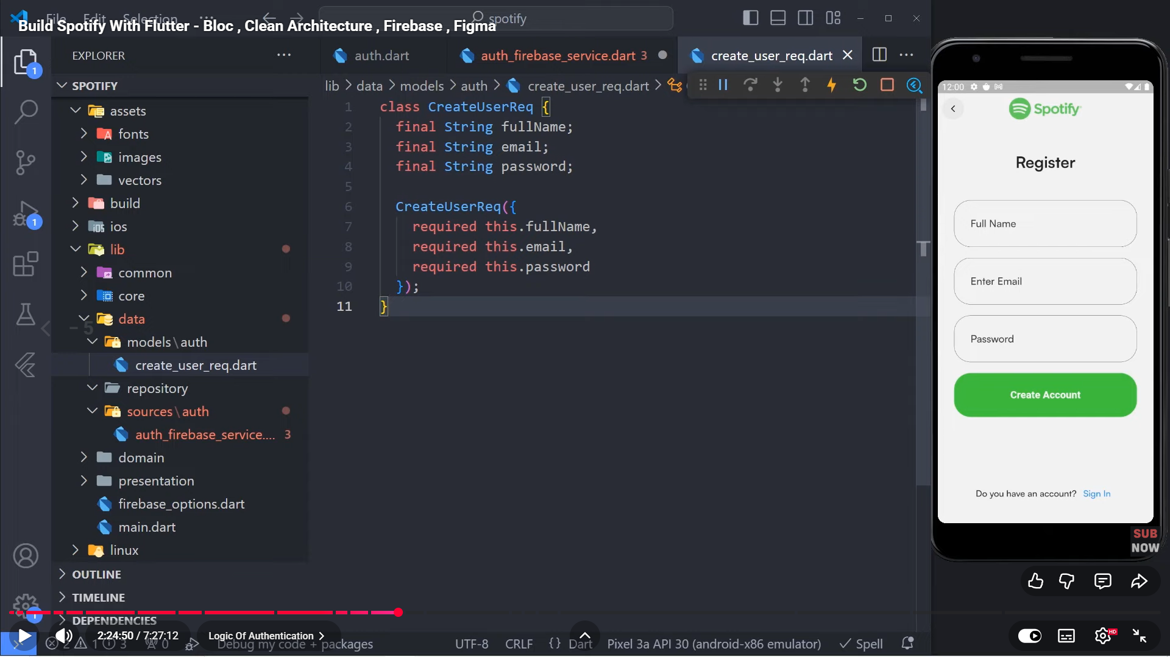

1. Add extension get_it
2. Create file service_locator in lib

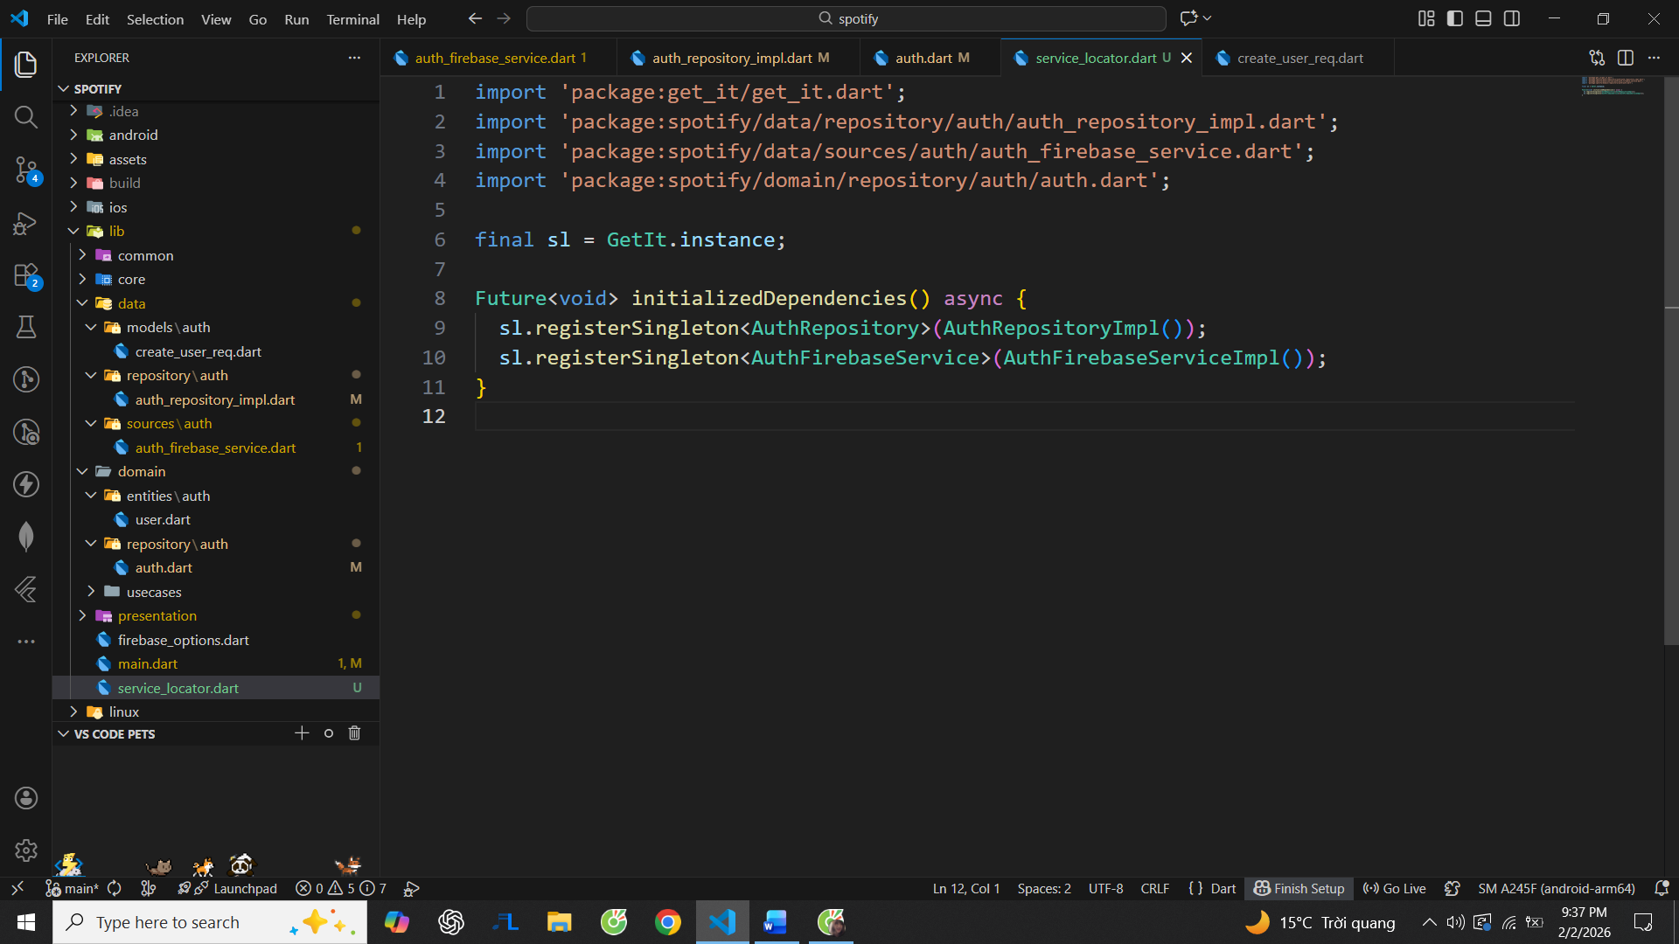

1. Create file auth_repository_impl in data/repository



1. Create usecase.dart in configs/usecase

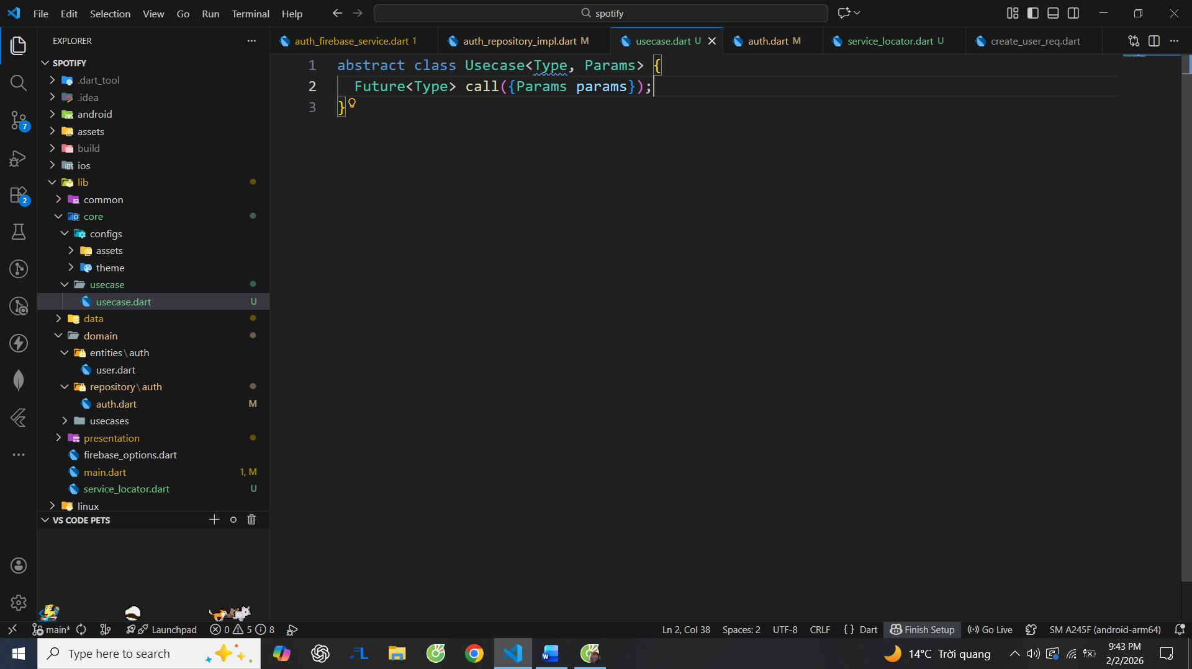

1. Add extension dartz
2. Auth_firebase_service will be like this:

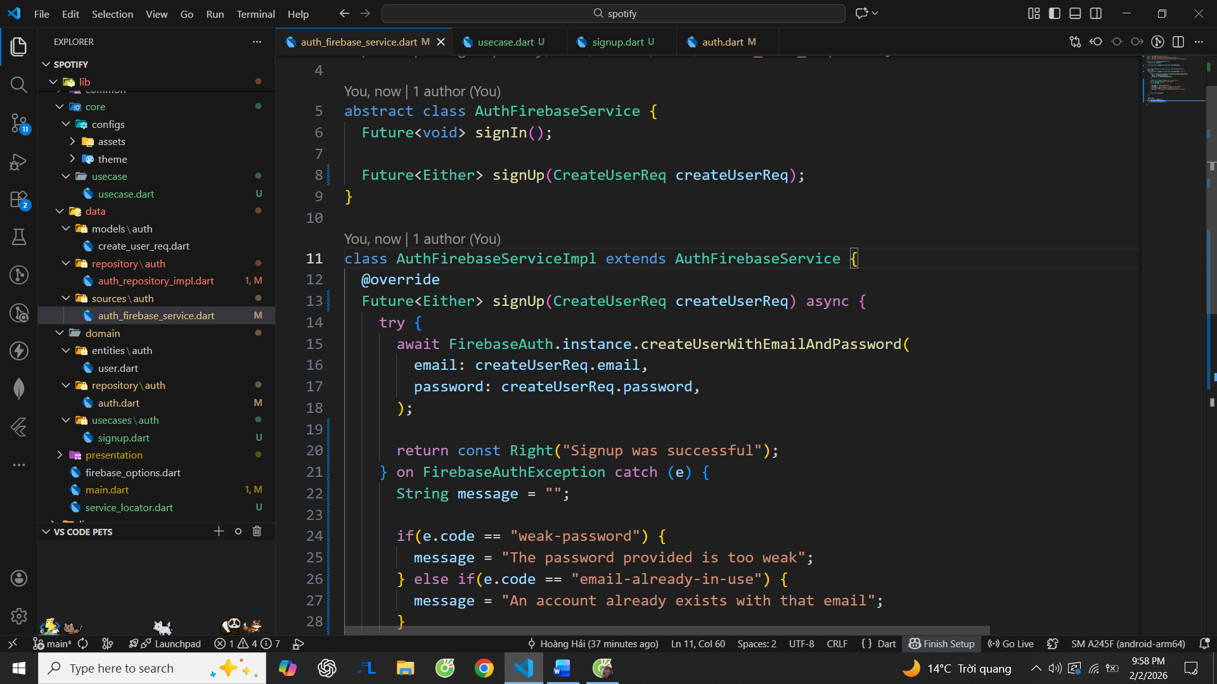

1. In signup in presentation add some codes:

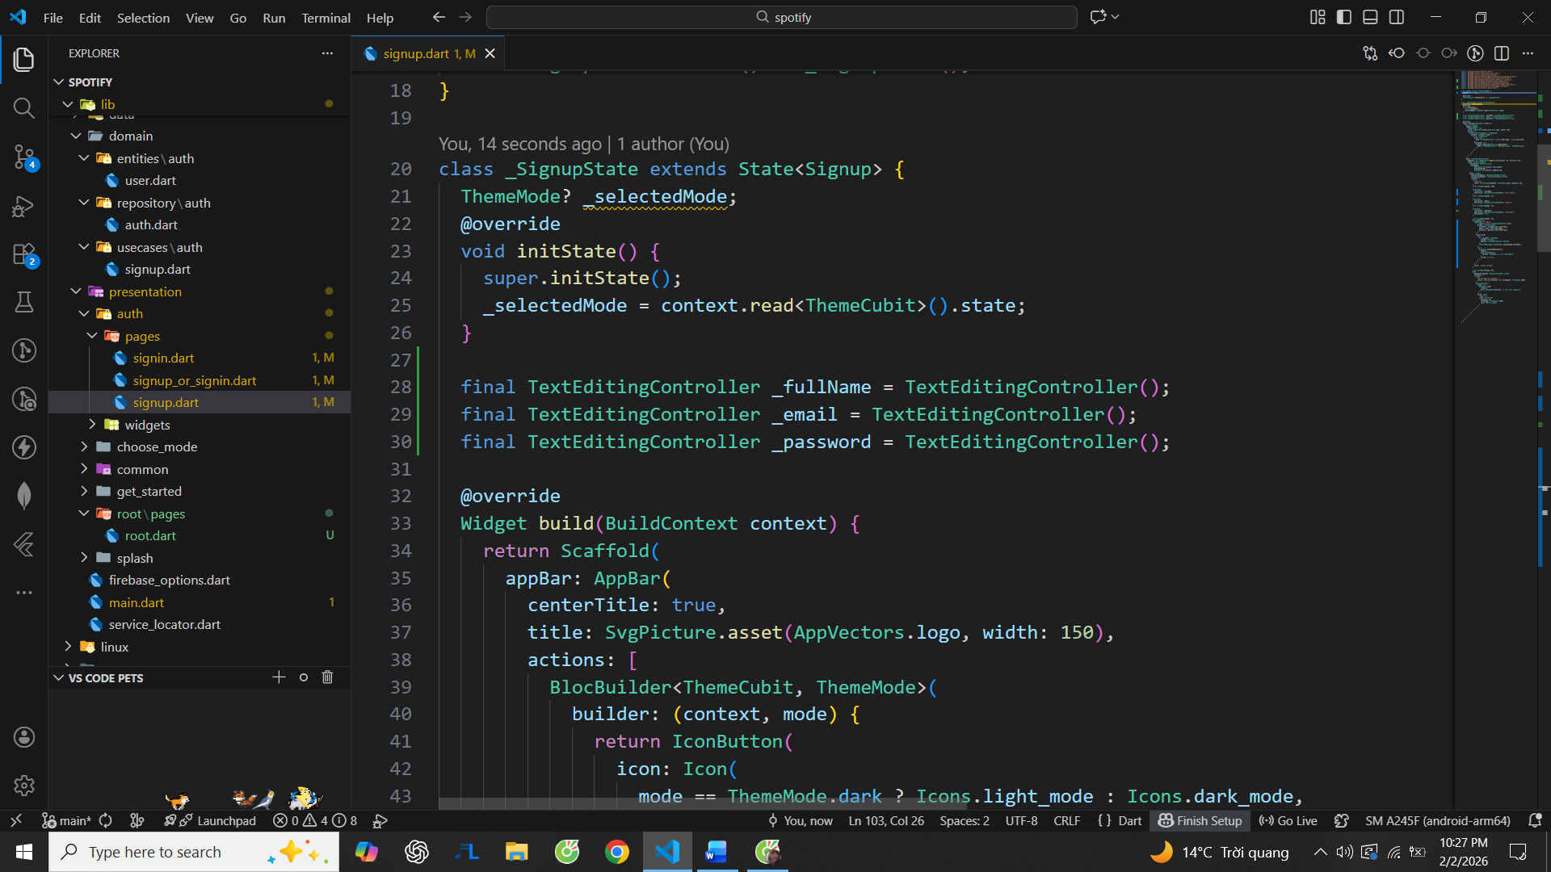

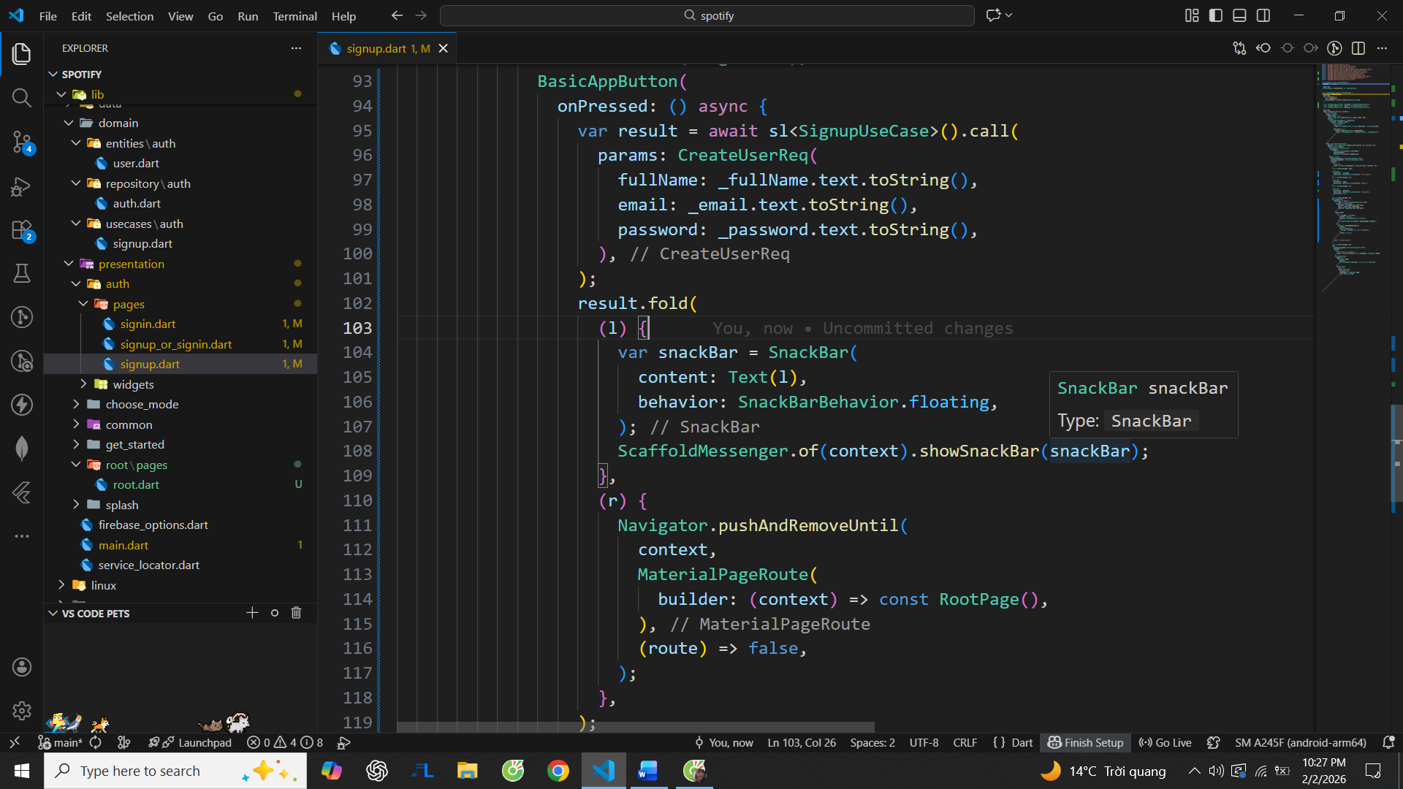

1. I’ve identified and fixed the issue where the app was stuck on the splash screen.

**Root cause:**  
The app was awaiting Firebase.initializeApp() inside main().  
On Android, Firebase initialization can block (especially on emulator or when Google Play Services/configuration is incomplete). Because runApp() was never reached, Flutter UI was not rendered, while the native splash screen kept showing—making it look like the app was frozen.

**Why there was no error:**  
Firebase does not fail fast in this case. It waits silently, so there was no red log or crash.

1. **Fix:**

Removed Firebase initialization from main()

Let the app render UI first

Initialized Firebase asynchronously inside the splash/initial screen instead

This prevents blocking app startup and makes the behavior deterministic.